The main assignment + Extra points

close all

clear

clc

%% rule 4

pattern1=zeros(17,17);

pattern2=zeros(17,17);

pattern3=zeros(17,17);

pattern4=zeros(17,17);

%pattern 1

for i = 1:17

pattern1(i,i) = 1;

pattern1(i,17+1-i) = 1;

end

%pattern2

for i = 1:(17);

pattern2(i,8) = 1; % Top left to center

pattern2(8,i) = 1; % Double the thickness

end

% pattern3

for j = 1:17

pattern3(j,5) = 1;

pattern3(j,12) = 1;

pattern3(8,5:12) = 1;

end

% pattern 4

for i = 2:17-1

pattern4(i,2) = 1; % Top horizontal line

pattern4(i,17-1) = 1; % Bottom horizontal line

end

for j = 2:17-1

pattern4(2,j) = 1; % Left vertical line

pattern4(17-1,j) = 1; % Right vertical line

end

% Combine all patterns into a single array

all_patterns = zeros(17,17,4);

all_patterns(:,:,1) = pattern1;

all_patterns(:,:,2) = pattern2;

all_patterns(:,:,3) = pattern3;

all_patterns(:,:,4) = pattern4;

f1=figure

% Plot the patterns

for i = 1:4

subplot(2,2,i);

imshow(all_patterns(:,:,i));

title(sprintf('Pattern %d', i));

end

saveas(f1, sprintf('1.png'));

dt = 0.001; % time step for simulation

tau = 0.010; % time constant for cells

tmax = 1; % maximum time to wait

time = 0:dt:tmax; %time vector

N_t = length(time);

N_unit=289;

r_max=50;

I_threshold=10;

del_I=1;

tau_r=10e-3;

pattern=zeros(17,17);

W=ones(N_unit,N_unit)*(-0.3/N_unit);

figure

for trial = 1:400+4

r_i = zeros(N_t,N_unit);

pattern_no = randi(4);

input_rand = all_patterns(:,:,pattern_no);

prob = find(rand(N_unit,1) < 0.1 );

input_rand(prob) = 1-input_rand(prob);

for i = 2:N_t

if ( i <N_t/ 2 )

I_i = input_rand(:)'*50 + r_i(i-1,:)*W;

else

I_i= r_i(i-1,:)*W;

end

r_i(i,:) = r_i(i-1,:) + dt/tau_r*((r_max./(1+exp(-(I_i-I_threshold)/del_I)))-r_i(i-1,:));

end

pattern(:) = r_i(end,:);

rate_t = 25;

epsilonp = 0.1/N_unit;

epsilonn = 0.25*epsilonp;

dW = epsilonp*(double(r_i'>rate_t))*(double(r_i>rate_t)) - epsilonn*(double(r_i'<rate_t))*(double(r_i>rate_t));

W = W+dW*dt;

W = min(W,8/N_unit);

W = max(W,-8/N_unit);

if ( mod(trial,100) < 5)

figure(pattern_no)

subplot(2,1,1)

imagesc(input_rand) % Input to network

subplot(2,1,2)

imagesc(pattern) % Response at end of trial

drawnow

caxis([0 r_max])

end

end

for trial = 1:4

rate = zeros(N_t,N_unit);

pattern_no = trial;

% Now set the chosen pattern to be the current trial's input pattern

input_rand = all_patterns(:,:,pattern_no);

prob = find(rand(N_unit,1) < 0.1 );

input_rand(prob) = 1-input_rand(prob)

f44=figure(44)

subplot('Position',[0.03+0.25*(trial-1) 0.52 0.2 0.35])

imagesc(input_rand); % View input patterns

set(gca,'XTick',[])

set(gca,'YTick',[])

title(strcat(['Final Input ', ' ', num2str(pattern_no)]))

colormap(gray)

for i = 2:N_t

if ( i <N_t/ 2 )

I_i = input_rand(:)'*50 + r_i(i-1,:)*W;

else

I_i= r_i(i-1,:)*W;

end

r_i(i,:) = r_i(i-1,:) + dt/tau_r*((r_max./(1+exp(-(I_i-I_threshold)/del_I)))-r_i(i-1,:));

end

pattern(:) = r_i(end,:);

% Finally plot all data on one figure

subplot('Position',[0.03+0.25*(trial-1) 0.04 0.2 0.35])

imagesc(pattern);

set(gca,'XTick',[])

set(gca,'YTick',[])

title(strcat(['Final Response ', ' ', num2str(pattern_no)]))

colormap(gray)

end

saveas(f44, sprintf('44.png'));

%% rule 2

%clf

pattern1=zeros(17,17);

pattern2=zeros(17,17);

pattern3=zeros(17,17);

pattern4=zeros(17,17);

%pattern 1

for i = 1:17

pattern1(i,i) = 1;

pattern1(i,17+1-i) = 1;

end

%pattern2

for i = 1:(17);

pattern2(i,8) = 1; % Top left to center

pattern2(8,i) = 1; % Double the thickness

end

% pattern3

for j = 1:17

pattern3(j,5) = 1;

pattern3(j,12) = 1;

pattern3(8,5:12) = 1;

end

% pattern 4

for i = 2:17-1

pattern4(i,2) = 1; % Top horizontal line

pattern4(i,17-1) = 1; % Bottom horizontal line

end

for j = 2:17-1

pattern4(2,j) = 1; % Left vertical line

pattern4(17-1,j) = 1; % Right vertical line

end

% Combine all patterns into a single array

all_patterns = zeros(17,17,4);

all_patterns(:,:,1) = pattern1;

all_patterns(:,:,2) = pattern2;

all_patterns(:,:,3) = pattern3;

all_patterns(:,:,4) = pattern4;

f11=figure

% Plot the patterns

for i = 1:4

subplot(2,2,i);

imshow(all_patterns(:,:,i));

title(sprintf('Pattern %d', i));

end

dt = 0.001; % time step for simulation

tau = 0.010; % time constant for cells

tmax = 1; % maximum time to wait

time = 0:dt:tmax; %time vector

N_t = length(time);

N_unit=289;

r_max=50;

I_threshold=10;

del_I=1;

tau_r=10e-3;

pattern=zeros(17,17);

W=ones(N_unit,N_unit)*(-0.3/N_unit);

figure

for trial = 1:400+4

r_i = zeros(N_t,N_unit);

pattern_no = randi(4);

input_rand = all_patterns(:,:,pattern_no);

prob = find(rand(N_unit,1) < 0.1 );

input_rand(prob) = 1-input_rand(prob);

for i = 2:N_t

if ( i <N_t/ 2 )

I_i = input_rand(:)'*50 + r_i(i-1,:)*W;

else

I_i= r_i(i-1,:)*W;

end

r_i(i,:) = r_i(i-1,:) + dt/tau_r*((r_max./(1+exp(-(I_i-I_threshold)/del_I)))-r_i(i-1,:));

end

pattern(:) = r_i(end,:);

rate_t = 25;

epsilonp = 0.1/N_unit;

epsilonn = 0.15*epsilonp;

dW = epsilonp*(double(r_i'>rate_t))*(double(r_i>rate_t)) -2* epsilonn*(double(r_i'<rate_t))*(double(r_i>rate_t));

W = W+dW*dt;

W = min(W,8/N_unit);

W = max(W,-8/N_unit);

if ( mod(trial,100) < 5)

figure(pattern_no)

subplot(2,1,1)

imagesc(input_rand) % Input to network

subplot(2,1,2)

imagesc(pattern) % Response at end of trial

drawnow

caxis([0 r_max])

end

end

for trial = 1:4

rate = zeros(N_t,N_unit);

pattern_no = trial;

% Now set the chosen pattern to be the current trial's input pattern

input_rand = all_patterns(:,:,pattern_no);

prob = find(rand(N_unit,1) < 0.1 );

input_rand(prob) = 1-input_rand(prob)

f22=figure(22)

subplot('Position',[0.03+0.25*(trial-1) 0.52 0.2 0.35])

imagesc(input_rand); % View input patterns

set(gca,'XTick',[])

set(gca,'YTick',[])

title(strcat(['Final Input ', ' ', num2str(pattern_no)]))

colormap(gray)

for i = 2:N_t

if ( i <N_t/ 2 )

I_i = input_rand(:)'*50 + r_i(i-1,:)*W;

else

I_i= r_i(i-1,:)*W;

end

r_i(i,:) = r_i(i-1,:) + dt/tau_r*((r_max./(1+exp(-(I_i-I_threshold)/del_I)))-r_i(i-1,:));

end

pattern(:) = r_i(end,:);

% Finally plot all data on one figure

figure(22)

subplot('Position',[0.03+0.25*(trial-1) 0.04 0.2 0.35])

imagesc(pattern);

set(gca,'XTick',[])

set(gca,'YTick',[])

title(strcat(['Final Response ', ' ', num2str(pattern_no)]))

colormap(gray)

end

saveas(f22, sprintf('22.png'));

%% rule 3

pattern1=zeros(17,17);

pattern2=zeros(17,17);

pattern3=zeros(17,17);

pattern4=zeros(17,17);

%pattern 1

for i = 1:17

pattern1(i,i) = 1;

pattern1(i,17+1-i) = 1;

end

%pattern2

for i = 1:(17);

pattern2(i,8) = 1; % Top left to center

pattern2(8,i) = 1; % Double the thickness

end

% pattern3

for j = 1:17

pattern3(j,5) = 1;

pattern3(j,12) = 1;

pattern3(8,5:12) = 1;

end

% pattern 4

for i = 2:17-1

pattern4(i,2) = 1;

pattern4(i,17-1) = 1;

end

for j = 2:17-1

pattern4(2,j) = 1;

pattern4(17-1,j) = 1;

end

% Combine all patterns into a single array

all_patterns = zeros(17,17,4);

all_patterns(:,:,1) = pattern1;

all_patterns(:,:,2) = pattern2;

all_patterns(:,:,3) = pattern3;

all_patterns(:,:,4) = pattern4;

f1=figure

% Plot the patterns

for i = 1:4

subplot(2,2,i);

imshow(all_patterns(:,:,i));

title(sprintf('Pattern %d', i));

end

saveas(f1, sprintf('1.png'));

dt = 0.001; % time step for simulation

tau = 0.010; % time constant for cells

tmax = 1; % maximum time to wait

time = 0:dt:tmax; %time vector

N_t = length(time);

N_unit=289;

r_max=50;

I_threshold=10;

del_I=1;

tau_r=10e-3;

pattern=zeros(17,17);

W=ones(N_unit,N_unit)*(-0.3/N_unit);

figure

for trial = 1:400+4

r_i = zeros(N_t,N_unit);

pattern_no = randi(4);

input_rand = all_patterns(:,:,pattern_no);

prob = find(rand(N_unit,1) < 0.1 );

input_rand(prob) = 1-input_rand(prob);

for i = 2:N_t

if ( i <N_t/ 2 )

I_i = input_rand(:)'*50 + r_i(i-1,:)*W;

else

I_i= r_i(i-1,:)*W;

end

r_i(i,:) = r_i(i-1,:) + dt/tau_r*((r_max./(1+exp(-(I_i-I_threshold)/del_I)))-r_i(i-1,:));

end

pattern(:) = r_i(end,:);

rate_t = 25;

epsilonp = 0.1/N_unit;

epsilonn = 0.4*epsilonp;

dW = epsilonp*(double(r_i'>rate_t))*(double(r_i>rate_t)) - epsilonn*(double(r_i'<rate_t))*(double(r_i>rate_t));

W = W+dW*dt;

W = min(W,8/N_unit);

W = max(W,-8/N_unit);

if ( mod(trial,100) < 5)

figure(pattern_no)

subplot(2,1,1)

imagesc(input_rand) % Input to network

subplot(2,1,2)

imagesc(pattern) % Response at end of trial

drawnow

caxis([0 r_max])

end

end

for trial = 1:4

rate = zeros(N_t,N_unit);

pattern_no = trial;

% Now set the chosen pattern to be the current trial's input pattern

input_rand = all_patterns(:,:,pattern_no);

prob = find(rand(N_unit,1) < 0.1 );

input_rand(prob) = 1-input_rand(prob)

f33=figure(33)

subplot('Position',[0.03+0.25*(trial-1) 0.52 0.2 0.35])

imagesc(input_rand); % View input patterns

set(gca,'XTick',[])

set(gca,'YTick',[])

title(strcat(['Final Input ', ' ', num2str(pattern_no)]))

colormap(gray)

for i = 2:N_t

if ( i <N_t/ 2 )

I_i = input_rand(:)'*50 + r_i(i-1,:)*W;

else

I_i= r_i(i-1,:)*W;

end

r_i(i,:) = r_i(i-1,:) + dt/tau_r*((r_max./(1+exp(-(I_i-I_threshold)/del_I)))-r_i(i-1,:));

end

pattern(:) = r_i(end,:);

% Finally plot all data on one figure

subplot('Position',[0.03+0.25*(trial-1) 0.04 0.2 0.35])

imagesc(pattern);

set(gca,'XTick',[])

set(gca,'YTick',[])

title(strcat(['Final Response ', ' ', num2str(pattern_no)]))

colormap(gray)

end

saveas(f33, sprintf('33.png'));

%% rule 1

pattern1=zeros(17,17);

pattern2=zeros(17,17);

pattern3=zeros(17,17);

pattern4=zeros(17,17);

%pattern 1

for i = 1:17

pattern1(i,i) = 1;

pattern1(i,17+1-i) = 1;

end

%pattern2

for i = 1:(17);

pattern2(i,8) = 1; % Top left to center

pattern2(8,i) = 1; % Double the thickness

end

% pattern3

for j = 1:17

pattern3(j,5) = 1;

pattern3(j,12) = 1;

pattern3(8,5:12) = 1;

end

% pattern 4

for i = 2:17-1

pattern4(i,2) = 1; % Top horizontal line

pattern4(i,17-1) = 1; % Bottom horizontal line

end

for j = 2:17-1

pattern4(2,j) = 1; % Left vertical line

pattern4(17-1,j) = 1; % Right vertical line

end

% Combine all patterns into a single array

all_patterns = zeros(17,17,4);

all_patterns(:,:,1) = pattern1;

all_patterns(:,:,2) = pattern2;

all_patterns(:,:,3) = pattern3;

all_patterns(:,:,4) = pattern4;

f1=figure

% Plot the patterns

for i = 1:4

subplot(2,2,i);

imshow(all_patterns(:,:,i));

title(sprintf('Pattern %d', i));

end

saveas(f1, sprintf('1.png'));

dt = 0.001; % time step for simulation

tau = 0.010; % time constant for cells

tmax = 1; % maximum time to wait

time = 0:dt:tmax; %time vector

N_t = length(time);

N_unit=289;

r_max=50;

I_threshold=10;

del_I=1;

tau_r=10e-3;

pattern=zeros(17,17);

W=ones(N_unit,N_unit)*(-0.3/N_unit);

figure

for trial = 1:400+4

r_i = zeros(N_t,N_unit);

pattern_no = randi(4);

input_rand = all_patterns(:,:,pattern_no);

prob = find(rand(N_unit,1) < 0.1 );

input_rand(prob) = 1-input_rand(prob);

for i = 2:N_t

if ( i <N_t/ 2 )

I_i = input_rand(:)'*50 + r_i(i-1,:)*W;

else

I_i= r_i(i-1,:)*W;

end

r_i(i,:) = r_i(i-1,:) + dt/tau_r*((r_max./(1+exp(-(I_i-I_threshold)/del_I)))-r_i(i-1,:));

end

pattern(:) = r_i(end,:);

rate_t = 25;

epsilonp = 0.1/N_unit;

epsilonn = 0.0;

dW = epsilonp*(double(r_i'>rate_t))*(double(r_i>rate_t)) ;

W = W+dW*dt;

W = min(W,8/N_unit);

W = max(W,-8/N_unit);

W = W - ones(N_unit,1)*mean(W)-0.3/N_unit;

if ( mod(trial,100) < 5)

figure(pattern_no)

subplot(2,1,1)

imagesc(input_rand) % Input to network

subplot(2,1,2)

imagesc(pattern) % Response at end of trial

drawnow

caxis([0 r_max])

end

end

for trial = 1:4

rate = zeros(N_t,N_unit);

pattern_no = trial;

% Now set the chosen pattern to be the current trial's input pattern

input_rand = all_patterns(:,:,pattern_no);

prob = find(rand(N_unit,1) < 0.1 );

input_rand(prob) = 1-input_rand(prob)

f11=figure(11)

subplot('Position',[0.03+0.25*(trial-1) 0.52 0.2 0.35])

imagesc(input_rand); % View input patterns

set(gca,'XTick',[])

set(gca,'YTick',[])

title(strcat(['Final Input ', ' ', num2str(pattern_no)]))

colormap(gray)

for i = 2:N_t

if ( i <N_t/ 2 )

I_i = input_rand(:)'*50 + r_i(i-1,:)*W;

else

I_i= r_i(i-1,:)*W;

end

r_i(i,:) = r_i(i-1,:) + dt/tau_r*((r_max./(1+exp(-(I_i-I_threshold)/del_I)))-r_i(i-1,:));

end

pattern(:) = r_i(end,:);

% Finally plot all data on one figure

subplot('Position',[0.03+0.25*(trial-1) 0.04 0.2 0.35])

imagesc(pattern);

set(gca,'XTick',[])

set(gca,'YTick',[])

title(strcat(['Final Response ', ' ', num2str(pattern_no)]))

colormap(gray)

end

saveas(f11, sprintf('11.png'));

The patterns I used are as follows:

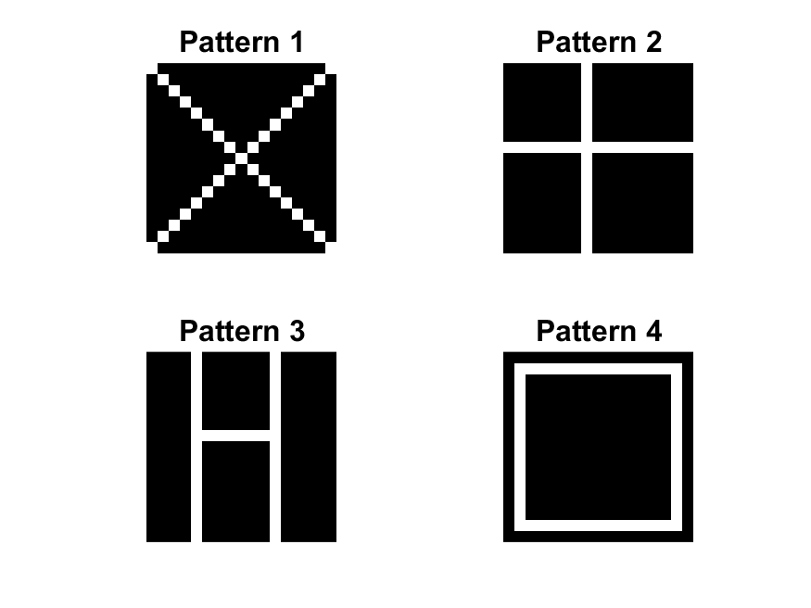

For rule 1 the final result is:

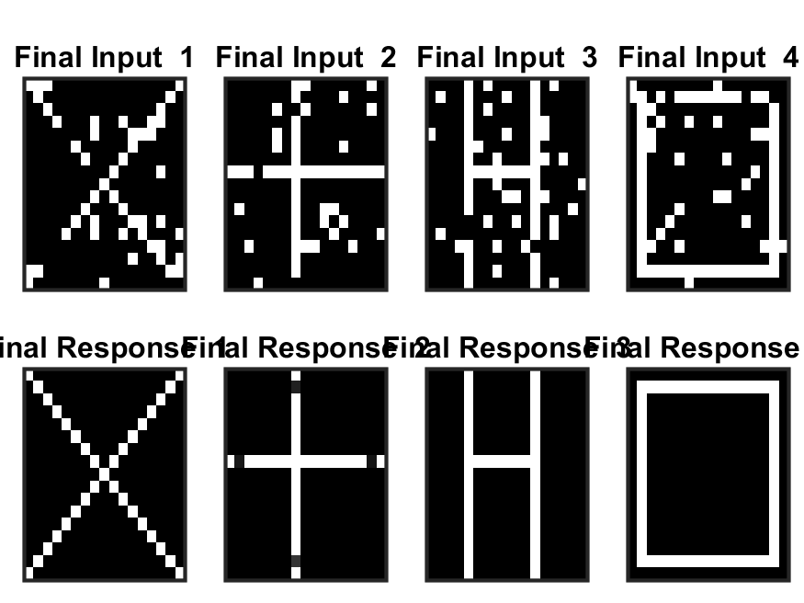

Frequent successful recognition of these patterns likely triggered LTP. Repeated pre-synaptic firing corresponding to these patterns, along with post-synaptic neurons firing above their thresholds, would have led to increased calcium influx and LTP, stengthen the connections for these specific patterns.The presented figure with a cross with empty spots suggests that some neurons representing the complete cross might not fire at all (because there's no corresponding lit pixel to stimulate them) or not provide sufficient excitatory input . This lack of co-activation with connected neurons doesn't trigger potentiation (since it relies on co-firing), and the existing connections might remain unchanged. However, the rule doesn't explicitly incorporate LTD in the classical sense.

For rule 2 the final result is:

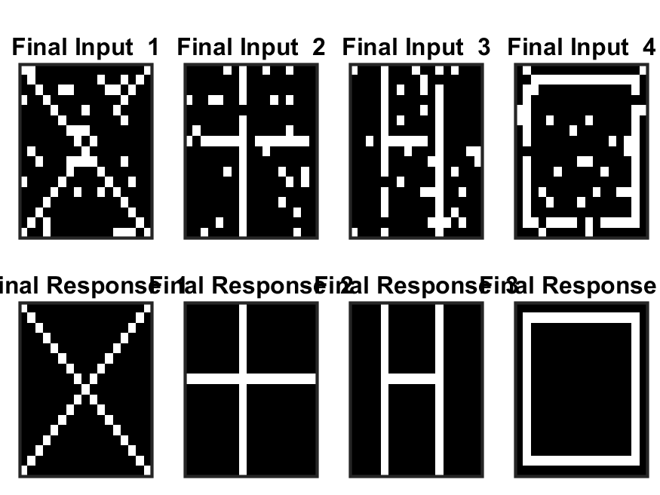

This indicates well-balanced LTP and LTD across all patterns. Encounters with each pattern likely triggered LTP for its specific recognition pathway, while encountering non-matching patterns didn't trigger enough stimulation for LTP and might have even induced slight LTD, keeping irrelevant pathways weak. This balance between strengthening the correct connections (LTP) and weakening irrelevant ones (LTD) allows for accurate recognition of all patterns.

For rule 3 the final result is:

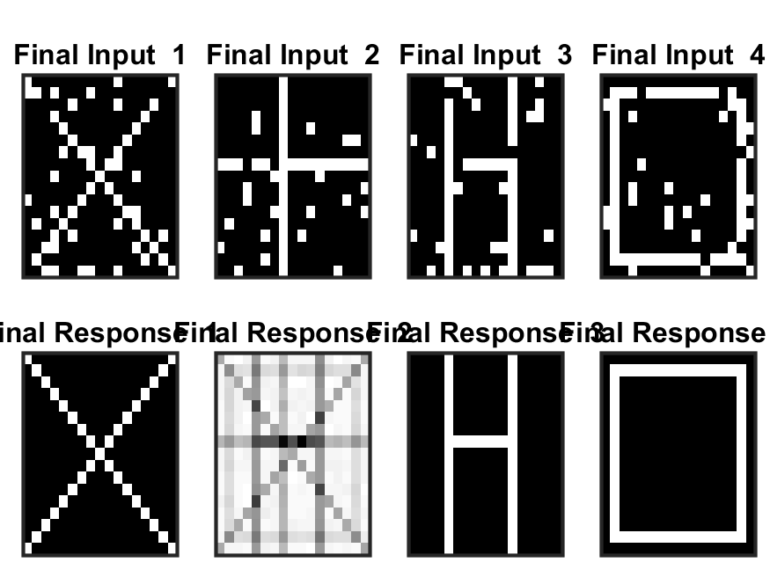

Correct recognition of X, H, and Square suggests strong synaptic connections between the input patterns and the correct output neurons for X, H, and Square. Frequent exposure to these patterns with successful recognition likely triggered LTP, strengthening these connections. Misrecognition of Cross (confusion with all patterns) suggests a more significant LTD effect on the complete cross recognition pathway. I think repeated encounters with incomplete crosses have triggered excessive LTD. The presynaptic neurons stimulated by the incomplete pattern might not reach their firing threshold, or the incomplete pattern do not provide enough overall excitatory input for the post-synaptic neurons to reach their threshold. This could lead to a significant weakening of the connections for a full cross, causing confusion with other patterns that have some overlapping features with the incomplete cross.

For rule 4 the final result is:

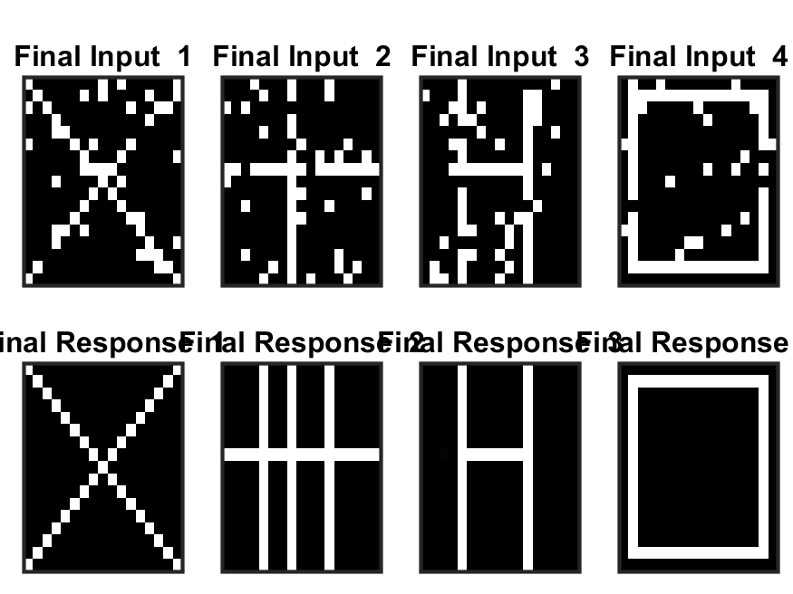

Correct recognition of X, H, and Square suggests strong synaptic connections between the input patterns and the correct output neurons for X, H, and Square. Frequent exposure to these patterns with successful recognition likely triggered LTP, strengthening these connections. The misrecognition of cross (Confused with H) is because the incomplete cross have some shared features with the H pattern (H horiziontal line). These shared features could unintentionally stimulate the pre-synaptic neurons in the H recognition pathway, causing them to reach their firing threshold. Additionally, the corrupted input pattern containing these features provide enough excitatory input for the post-synaptic neurons in the H pathway to reach their threshold. This coordinated firing in the H pathway could trigger LTP, strengthening the connections for recognizing H-like patterns.

Now in another experiment if I increase the number of new trials from 4 to 14, I can see that the pattern 1 and 2 can recognize the patterns fully (rule 2 seems to be the most robust, handling all patterns (uncorrupted and potentially some level of corruption) perfectly) but the performance of the rule 3 and 4 have not changed.

Rule 1:

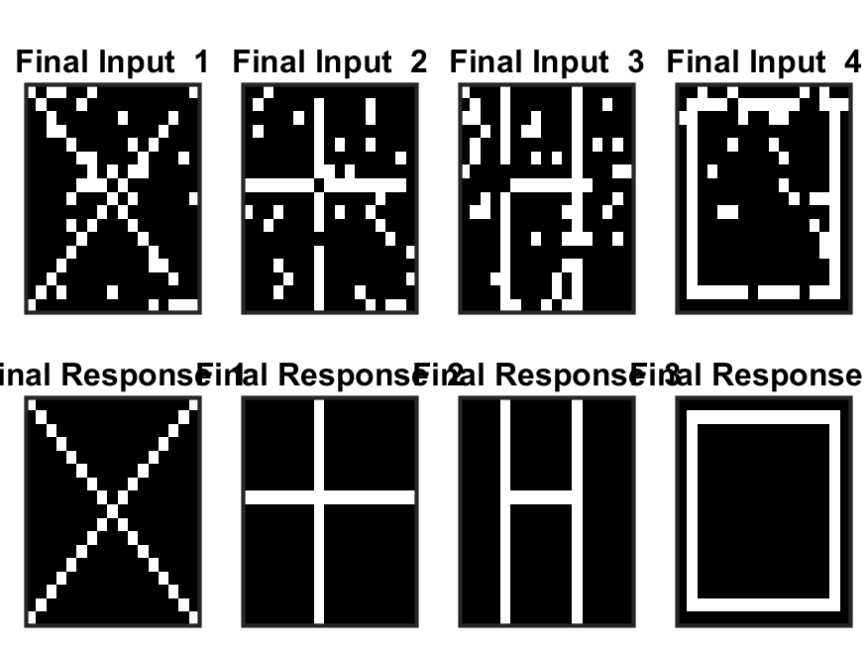

It seems that with more trials featuring these complete and correct patterns, LTP strengthens the existing connections between the specific features of each pattern and the corresponding output neurons dedicated to recognizing them. Over time, this reinforcement loop solidifies the recognition pathways for X, H, and Square, leading to perfect recognition with increased trials.